***This file provides the guide for the game ROCK PAPER SCISSORS:***

* ***From the main window click on your choice.***
* ***Then this window will pop up:***

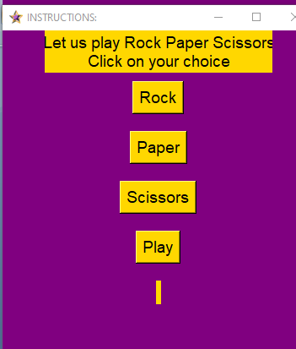

* ***Rock button will let you choose the option rock same with the remaining buttons.***
* ***By clicking the play button the computer will show the results of the game by displaying yours and computer’s choice.***